Nama : Berlian Alvina

Kelas : 5C

Nim : 18090005

**Source Code**

⦁ autoload.php : application/config

⦁ database.php : application/config

⦁ ModelUser.php : application/models

⦁ ModelBuku.php : application/models

**Membuat database Pustaka**

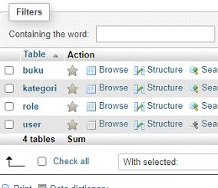

tabel user

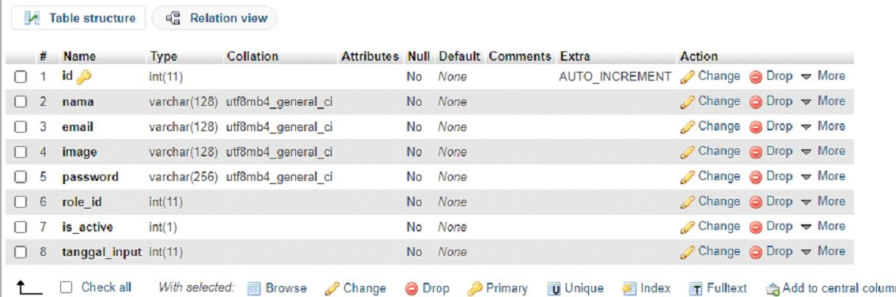

tabel buku

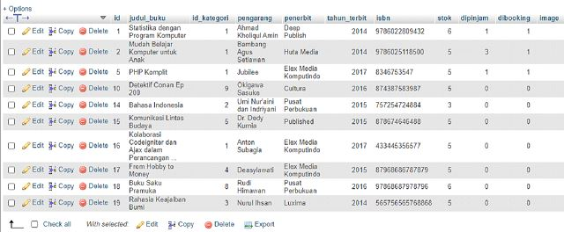

tabel role

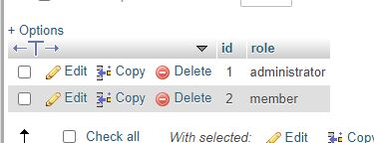

tabel kategori

